Python collects and monitors system data -- psutil
bbsmax 2021-08-21 20:36:00
python collects monitors data psutil

Hello everyone , I'm brother Chen ～
Today, I'd like to introduce a library that can obtain the current system information ——psutil
utilize psutil Library can get some information about the system , Such as cpu, Memory usage, etc , This allows you to view the current system usage , Collecting these information in real time can achieve the purpose of real-time monitoring system .

psutil library
psutil It's easy to install
pip install psutil
psutil What system information can the library get ？
psutil What are the functions
1. Memory usage
2. Disk usage
3.cpu Usage rate
4. The network interface sends and receives traffic
5. Get the current network speed
6. The current process of the system
...
The following is a demonstration through a specific code case

Memory usage
import psutil
# Memory
mem = psutil.virtual_memory()
# Total system memory
zj = float(mem.total) / 1024 / 1024 / 1024
# The system has used memory
ysy = float(mem.used) / 1024 / 1024 / 1024
# System free memory
kx = float(mem.free) / 1024 / 1024 / 1024
print(' Total system memory :%d.4GB' % zj)
print(' The system has used memory :%d.4GB' % ysy)
print(' System free memory :%d.4GB' % kx)

Gets the total memory of the current system , Used memory , And free memory
The unit of memory obtained here is bytes , So you need to divide by 1024 To G, The same is true below, so I won't repeat the explanation .

Get the system cpu Information
# Show cpu All logical information
print(psutil.cpu_times(percpu=True))
# see cpu Information of logical number
print(u" Logic CPU Number : %s" % psutil.cpu_count())
# see cpu Information about the number of Physics
print(u" Physics CPU Number : %s" % psutil.cpu_count(logical=False))
#CPU The usage rate of
cpu = (str(psutil.cpu_percent(1))) + '%'
print(u"cup Usage rate : %s" % cpu)
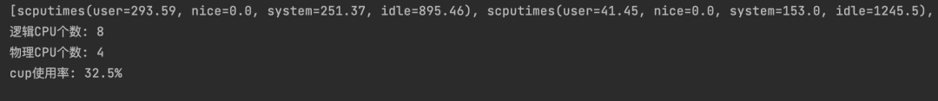
obtain cpu Information , And this machine cpu Number （ Including logic cpu Numbers and physics cpu Count ）, Current cpu Usage rate （ every other 1 Seconds to get once , Get and view real-time cpu Usage )

System disk usage
part = psutil.disk_partitions()
for i in part:
print(i)
dk = psutil.disk_usage('/')
print(dk)
# Total disk
total = dk.total / 1024 / 1024 / 1024
used = dk.used / 1024 / 1024 / 1024
free = dk.free / 1024 / 1024 / 1024
print(' Total system disks :%d.3GB' % total)
print(' The system is already using disk :%d.3GB' % used)
print(' System free disk :%d.3GB' % free)
print(u" Disk usage : %s%%" % dk.percent)
# Get the total number of disks io Number , Read and write information
print(psutil.disk_io_counters())
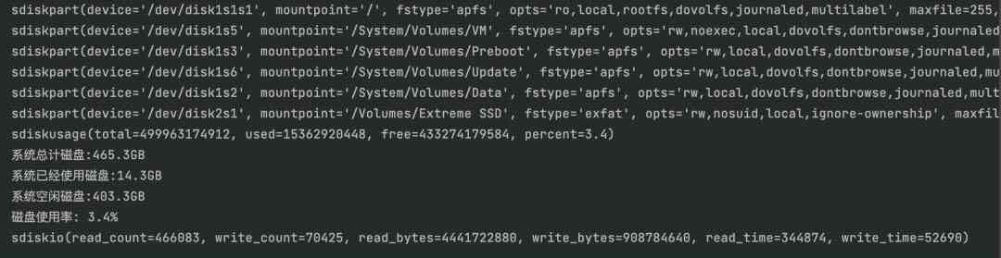
The first few lines are the disk information that the current system can access
Among them the first 1 That's ok mountpoint='/', Indicates the current local default disk
Among them the first 6 That's ok mountpoint='/Volumes/Extreme SSD', Indicates an external solid state mobile hard disk
Here is the local disk mountpoint='/' For example , Check disk usage （ Total capacity , Already used , Free capacity , Usage rate ）
The meaning of each field in the last line is as follows ：
"""
read_count read IO Count
write_count Write IO Count
read_bytes read IO Number of bytes
write_bytes Write IO Number of bytes
read_time Disk read time
write_time Disk write time
"""

Get the system network card information
# Get total network IO Information
print(psutil.net_io_counters())
# Send packet
print(" Send data bytes :", psutil.net_io_counters().bytes_sent,"bytes")
# Receive packets
print(" Receive data bytes :",psutil.net_io_counters().bytes_recv,"bytes")
# Output information of each network interface
net_counter = psutil.net_io_counters(pernic=True)
for i in net_counter:
print(" network card ："+i+" , Network card information ：",net_counter[i])
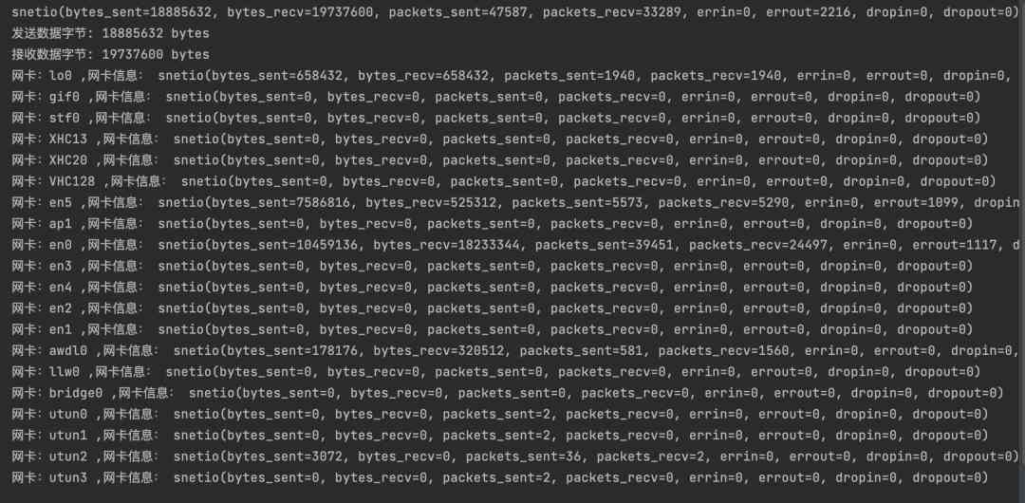
You can get which network cards exist in the current machine , And how much traffic is sent and received
Check whether the local network card is consistent in the terminal
mac and linux System commands ：ifconfig
window System commands ：ipconfig
Some screenshots are as follows ：
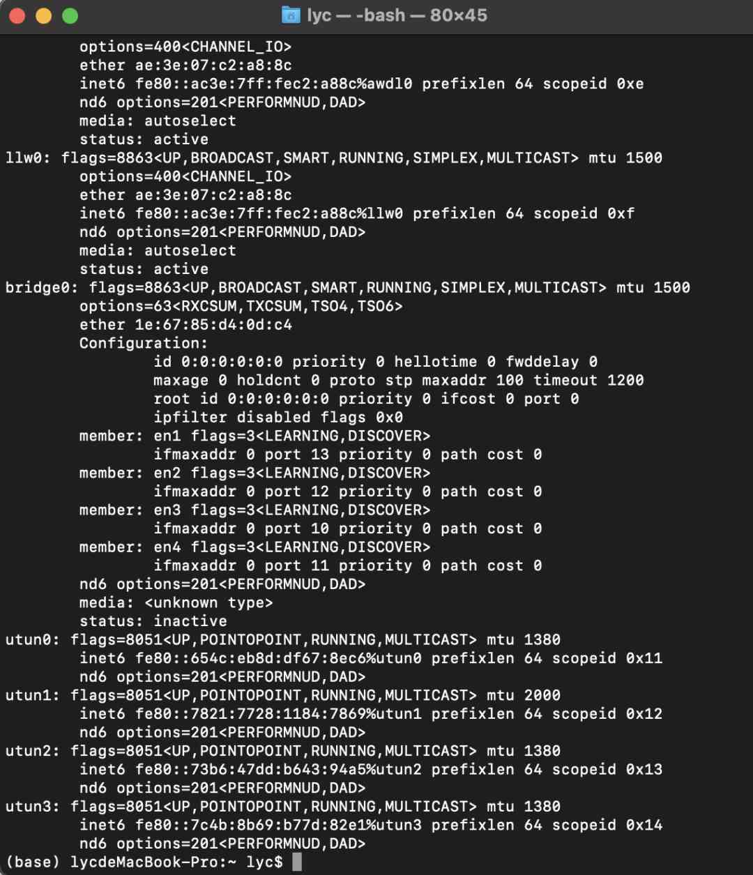
You can see that the network card data obtained by the program is consistent with that obtained by the local terminal
Get the current network speed
Obtain the current network speed by obtaining the traffic sent and received by the network card through the above program
s1 = psutil.net_io_counters(pernic=True)['en0']
time.sleep(1)
s2 = psutil.net_io_counters(pernic=True)['en0']
result = s2.bytes_recv - s1.bytes_recv
print(str('%d' % (result / 1024)) + 'kb/s')
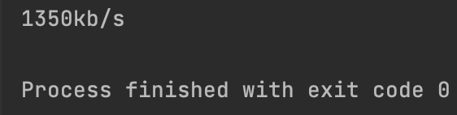
In code ['en0'] Said to get en0 Network card data , Because chenge's network card is en0
Finally, you can see the current network speed
Every 1 Seconds to execute the code can achieve real-time access to network speed
Other features
# System Up Time
# Convert to natural time format
print(datetime.datetime.fromtimestamp(psutil.boot_time ()).strftime("%Y-%m-%d %H: %M: %S"))
# Get the current system user login information
users = psutil.users()
for i in users:
print(i)
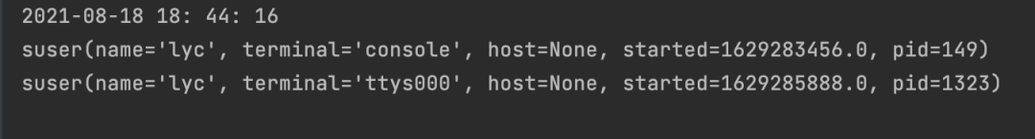
You can get the startup time of this machine , And the current users
Today's article is here
If you have any questions, please leave a message below to discuss ~

